Penn State University

Open Education Initiatives
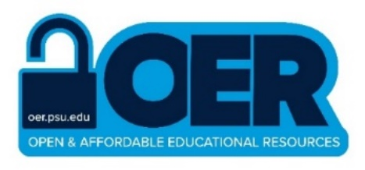Annual Report
2021-2022

Prepared by the OAER Working Group
oer.psu.edu

Table of Contents
About Us 3
2021-2022 Highlights 4
Introduction 5
What We’ve Done 6
The State of OER at Penn State 11
Achievements 15
What’s Next 19
Appendix: Sources 20

About Us
The cost of course materials present a barrier to success for many students—students’ access to open and high-quality course materials is paramount. In February 2017, Penn State’s Transforming Education Steering Committee charged the Open and Affordable Educational Resources (OAER) Working Group to implement the recommendations from the University’s 2016 OER Task Force Report, develop new programs related to OER, and pilot select OER initiatives.
Penn State’s OER efforts are coordinated by a university-wide Open and Affordable Educational Resources (OAER) Working Group which consists of individuals and teams from University Libraries; Teaching and Learning with Technology; the College of Earth and Mineral Sciences (EMS); WPSU; World Campus; student representatives from the University Park Undergraduate Association, Commonwealth Campus Student Government, and the World Campus Student Government; and the bookstore (Barnes & Noble). The OAER Working Group also includes an Instructional Advisory Group consisting of faculty from across the University.

PURPOSE
The role of the OAER working group is to guide, encourage, support, and assess the transformation of pedagogy, the enhancement of accessibility and equity, and the reduction of student costs through open education.

OAER Working Group Members

Rebecca Miller Waltz, co-chair, Associate Dean, University Libraries | Ann Taylor, co-chair, Assistant Dean for Distance Learning & Director, John A. Dutton E-Education Institute, College of Earth and Mineral Sciences | Brendan Berthold, Instructional Production Specialist, Office of Digital Learning | Gary Chinn, Director, eLearning Institute, College of Arts and Architecture | Aayush Dalal, Open Education Intern | Sara Davis, Instructional Designer, TLT | Angie Dick, Manager, Learning Design, TLT | Sydney Gibbard, UPUA student representative | Malena Gittler, Senior Instructional Designer, World Campus Learning Design | Jennifer Guyer, General Manager, Penn State Bookstore
Sarah Hamilton, Education Program Manager, WPSU | Matt Hansen, World Campus student representative | John Hoh, Interim Associate Vice President, TLT | Liz Huck, Director of Statewide Instructional Design | Toni Irvin, Director of Education and Engagement, WPSU | Bryan McGeary, Learning Design & Open Education Engagement Librarian | Todd Migliaccio, Associate Dean of Academic Affairs at Penn State University, Berks | Sara Peterson, Administrative Support Coordinator, University Libraries' Dean's Office | Crystal Ramsay, Interim Head, Educational Technology Services | Christina Riehman-Murphy, Open & Affordable Educational Resources Librarian | John Shank, Head Librarian, Berks Thun Library | Wade Shumaker, Instructional Production Specialist, TLT | Chris Stubbs, Director, Office of Digital Learning | Corey Wetherington, Open Education Infrastructure Specialist, Research Informatics & Publishing

2021-2022 Highlights

Thousands of Penn State students are impacted by OER

Across the 23 residential campuses that reported data from courses using OER, in the 2021 academic year, 3986 undergraduate students are enrolled in courses that are using OER. Many World Campus students took courses that are using library-licensed e-books. Faculty across 15 campuses reported using OER and usage has increased since the 2020-2021 academic year.

OER initiatives continue to grow

The 2021-2022 academic year saw the development of multiple new OER initiatives with involvement from new stakeholders.
- The Affordable Course Transformation (ACT) OER authoring began its 4th round.
- The 2021 University Libraries Giving Tuesday campaign enabled us to create OAER Leads, scaling up the Abington OER adoption grant to 8 campuses.
- University Libraries hired its first Bednar Intern that focused on open education, and it also partnered for the first time with the Nittany Lion Consulting Group to center the Penn State student perspective. The impact of working with students has informed our strategic initiatives moving forward.
- The OER Champion award, previously awarded by the Penn State Berks library, was expanded to 3 additional campus libraries: Abington, Lehigh Valley, Mont Alto.

Ongoing, sustainable funding is needed

Since 2016, Penn State’s OAER initiatives have relied in large part on funding provided by the Office of the Executive Vice President and Provost as well as significant volunteer efforts. This funding has been vital to our endeavors, paying for stipends and awards to incentivize and reward faculty for using and creating open and affordable educational resources, staff positions and services to support the creation and use of these resources, and institutional memberships in national and international organizations that help to position Penn State as a leader in this field. However, as this initial seed funding comes to an end, there is a need to secure sustainable funding to maintain and grow initiatives. In the present economic climate, it is imperative to pursue multiple avenues, such as funding from University administration, external grants, and donors.

Cross-campus collaboration leads to greater success

Penn State has multiple OER faculty-stipend/direct support initiatives which are sustained by cross-unit and cross-campus support. This team-based approach of stakeholders collaborating across campuses and units has allowed these OER initiatives to grow and be successful.

Introduction

OER are “teaching, learning, and research resources that are free of cost and access barriers, and which also carry legal permission for open use. Generally, this permission is granted by the use of an open license (for example, Creative Commons licenses, which allow anyone to freely use, adapt and share the resource-anytime, anywhere” (SPARC, n.d.).

Penn State has long been invested in providing access to equitable and affordable education and resources, as demonstrated by initiatives led by the University Libraries and colleges like Earth and Mineral Sciences. Over the past five years, University Libraries has led coordinated efforts surrounding open and affordable educational resources. A 2016 Open Educational Resources Task Force recommended a number of programmatic tasks, many of which have been accomplished through the Open & Affordable Educational Resources (OAER) Working Group of the Transforming Education Steering Committee. The OER program truly embodies Penn State University President Dr. Neeli Bendapudi’s ABCs of success by helping students with Academic preparedness, Belonging in their classes regardless of finances, and managing the Cost of education.
Implementing OER in coursework directly helps students lower the cost of their college education, but it also has many additional benefits:
- Student retention rates are as good or better in courses using OER when compared to courses using traditional materials (Colvard, Watson, & Park, 2018; Hilton et al, 2016).
- Students who enroll in more than one OER course take more credits than their peers (Griffiths et al, 2020).
- Instructors are able to innovate their instructional design while improving their students’ learning experiences by adopting OER (Froehlich, Nicosia, & Riehman-Murphy, 2022; DOERS3, 2020).
- Instructors and institutions are able to connect with an international network of peers that can collaborate on the development and improvement of new OER (Nascimbeni et al, 2021).
- Students have similar learning outcomes in courses that use open educational resources when compared with students using traditional textbooks (Clinton, Legerski, and Rhodes, 2019; Ozdemir & Hendricks, 2017).
At this point in time, we are poised to move OER into a strategic priority for the University, building from the strong foundation we have established and moving into a second phase of programmatic, strategic, and sustainable core functions associated with open and affordable educational resources. This will enable us to develop stronger structures for supporting and advancing OER efforts and establish ourselves as strong collaborators ready to partner with other Penn State units as well as national and global institutions, researchers, and groups.

What We’ve Done

Outreach

Open Ed Engagement Series
The OAER Working Group offered a series of virtual workshops on Open Education Engagement during the 2022 summer session. The workshops introduced Penn State faculty and staff — particularly instructors, librarians and instructional designers — to topics related to open education, with the potential to lower the costs of course materials for students. The initial three series, each with three to four sessions, covered such topics as adopting or customizing existing open and affordable course materials as well as opportunities and resources for engaging instructors in OAER initiatives. Future series will expand into other related topics.

Penn State Workshops and Presentations
Librarians and Instructional Designers across the Commonwealth developed and presented workshops to faculty, undergraduates, and graduate students to increase awareness of integration of open educational resources in course materials. In total they delivered 31 presentations to faculty this year and four to students. Members of the OAER Working Group presented on OER to the following Penn State units: Digital Learning Academic Council (DLAC), Online Coordinating Council (OCC), Teaching and Learning with Technology Course Liaison Meeting, University Park Undergraduate Association, World Campus Student Government, Commonwealth Campus Student Government, and University Libraries Student Advisory Board.
219
Faculty OER Consultations

Faculty Consultations
Members of the OAER working group regularly consulted with faculty on adopting and authoring OER in their courses.
Faculty and staff in University Libraries and Teaching and Learning with Technology had 219 consultations with faculty this year.

Facilitating Communication
In order to provide a more seamless intake process for instructors who are interested in using and/or creating open and affordable course materials, the Libraries added a new OER-focused queue within its existing LibAnswers system. This queue makes it possible to triage questions and consultation requests more easily. An intake form has been added to the Penn State OER website in order to increase the visibility of this service. We began promoting it further via New Faculty Orientation in August 2022 and hope to continue to do so in the future.

OER Publishing

ROAM
In late Fall 2021, the College of Earth and Mineral Sciences’ OER repository migrated to University Libraries and was rebranded as ROAM, Penn State’s Repository for Open and Affordable Materials. In a collaboration between Open Publishing and Libraries Strategic Technologies, significant infrastructure development was conducted on ROAM during the summer of 2022 in order to bring about cosmetic and functional enhancements to the site that better align the platform with peer repositories. There are currently 95 open resources (courses and textbooks) housed in ROAM, all of which were authored by Penn State faculty and all of which are suitable for undergraduate or upper-level high school instruction. Efforts to include additional Penn State resources (e.g., from other University repositories such as our Pressbooks catalog) are ongoing.

Penn State Authored OER Textbooks
We continue to support Penn State faculty in the production of OER. These materials reflect an increasingly diverse range of disciplines in the sciences, social sciences, and humanities. Below is a selection of OER textbooks published by Penn State faculty. These textbooks have been funded through a variety of sources, including the Affordable Course Transformation (ACT) program and the Pennsylvania Grants for Open and Affordable Learning (PA GOAL) program.

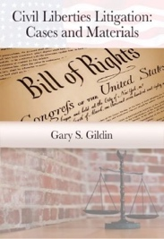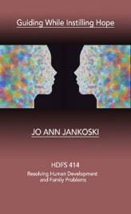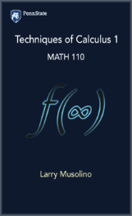
Selection of Penn State faculty authored OER for 2021-2022 AY

OAER Champion Award
Four Penn State campuses — Abington, Berks, Lehigh Valley and Mont Alto — awarded Penn State’s inaugural Open and Affordable Educational Resources (OAER) Champion Award during the spring 2022 semester. A collaboration between the University Libraries and the University-wide OAER Working Group, the OAER Champion Award is a pilot initiative recognizing excellence, innovation, and impact in OAER at Penn State campuses.

OER Website Remodel
A small team in the OAER Working Group redesigned oer.psu.edu as the landing place for the Penn State community who are seeking information about or support for using OER. This redesign was launched in Spring 2022. It includes news story highlights of OER initiatives at Penn State, a direct consultation request for support from the OER team, upcoming events, and a list of all previous and current OER grant faculty awardees.

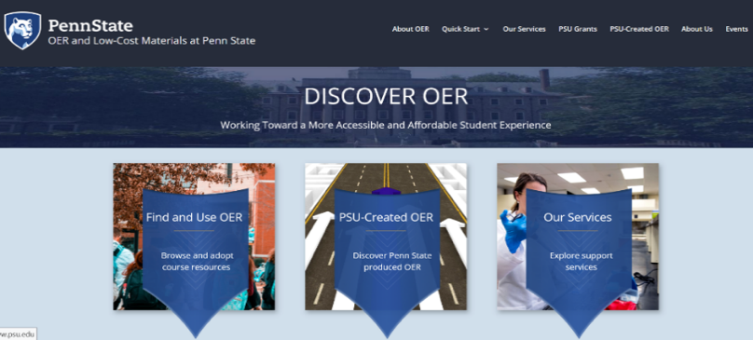
Redesigned oer.psu.edu website

Grants
Penn State Libraries was both the recipient of external state-funded grants and administer of grants to Penn State librarians and disciplinary faculty to fund open education projects.

External Grants
Four Penn State-led teams were awarded grants through PA GOAL, a program funded by the Pennsylvania Department of Education through the Office of Commonwealth Libraries to support the creation of open and affordable learning projects at institutions across Pennsylvania. In addition to the awardees (listed below), Bryan McGeary was selected to serve on the PA GOAL Advisory & Review Board.
- Abington: Christina Riehman-Murphy (Open and Affordable Educational Resources Librarian) and Marissa Nicosia, (Associate Professor of Renaissance Literature) developed an open pedagogy assignment in which undergraduate students are co-authoring an open anthology on premodern literature.
- Berks: Pauline Milwood (Assistant Professor of Hospitality Management) and Sarah Hartman-Caverly (Reference and Instruction Librarian) substantially revised and adapted an entrepreneurship-focused pop-up restaurant business guide to a cost-effective, OER text-alternative available to Hospitality Management students.

- Hazleton: Beatriz Glick (Associate Teaching Professor of Spanish) developed an Intermediate Spanish textbook featuring several modified integrated performance
assessments (IPAs), task-based communication activities that are drawn from Spanish or Spanish-influenced movies, poems, songs and other materials.
- Lehigh Valley: Alison Bonner (Assistant Teaching Professor of Mathematics), Larry Musolino (Lecturer of Mathematics), and Elizabeth Nelson (Reference and Instruction Librarian) created a workbook to support student learning in first-year math courses with an emphasis on foundational calculus. The workbook provides students with materials for additional practice and opportunities to test their learning, identify areas of struggle, and seek help without penalties for failure.

Internal Grants

OAER Leads
- Awarded grants to 34 faculty and 7 librarians across 8 Penn State campuses
- Supported OER and library-licensed adoptions and professional development

ACT Round 4
- Awarded grants to 7 faculty at 6 Penn State campuses
- Supported OER creation by Penn State faculty
- Awardees:
    - Behrend: Arpan Yagnik (Associate Professor of Advertising, Communication)
    - Carlisle: Samantha Prince (Assistant Professor of Law)
    - Harrisburg: Daniel Mallinson (Assistant Professor of Public Policy and Administration) and Eric Best (Assistant Professor of Homeland Security and Public Policy)
    - Lehigh Valley: Alison Bonner (Assistant Teaching Professor of Mathematics)
    - Mont Alto: Ermek Nurkhaidarov (Associate Professor of Mathematics)
    - University Park: Noel Habashy (Assistant Teaching Professor of International Agriculture)

Strategic Plan
The University Libraries OER and Open Pedagogy Strategic Action Team completed its yearlong work to fulfill its charge to enhance Libraries-wide support for OER at all campuses. More information about the team’s action items and deliverables can be found in its final report, which also includes links to accompanying data. The team, co-led by Bryan McGeary and Corey Wetherington, included Barb Eshbach, Katie Odhner, Andrew Marshall, and Christina Riehman-Murphy.

Collections
Through its collection development efforts, the University Libraries is providing faculty and students with a mixed ecosystem of textbook affordability solutions that includes access to more e-books, increased discoverability of OER, and tools to support the use of open materials in the classroom.

Increased Discoverability of Textbook Records
Each month, Digital Access Coordinator Jeff Edmunds adds records to the library catalog for newly available open access and OER titles from major sources, such as the Open Textbook Library and OAPEN. These records make it possible to easily find these resources within the library catalog instead of searching a variety of OA/OER repositories separately.

COVE
In Spring 2022, the Libraries Shared Content Leadership Group allocated $20,000 of one-time funds to acquire four years of access to COVE Studio, a database of open literature content with tools to create course anthologies, annotate, and create timelines and galleries. Currently, its largest areas of content are in Victorian, Romance, Medieval, and Renaissance Literature, but it is increasing its selection of texts from diverse authors.

E-books Added for Course Use
E-book usage for courses is another way to address affordability for students. Librarians across Penn State do direct outreach to faculty to increase awareness of e-book options for their courses. Selectors use collections funds to purchase unlimited user e-books when possible.

World Campus E-book Program
Since 2018, the University Libraries and World Campus have partnered on a program to license academic and university press books that are used in World Campus programs for university-wide use. Through this program, course designers are notified that an e-book is available, and they notify faculty. The e-books are then added to an associated course through the Libraries E-Reserves system in Canvas, and the faculty and students are notified. Faculty have the option to opt-out. The list of books can be found at https://student.worldcampus.psu.edu/E-book-program.

The State of OER at Penn State

Textbook Web Aggregator Data
Developed by Corey Wetherington, the Penn State Automated Textbook Aggregator (nicknamed “Petunia”) is a command-line application written in Python that automates the process of identifying the number of OAER that are used in Penn State courses in order to track the cost avoidance for our students and to connect students to University Libraries materials that are freely available for their use. Petunia utilizes (with permission) publicly listed data from Barnes & Noble and LionPATH. The application provides an incomplete picture of course materials usage at Penn State due to underreporting of course materials by faculty. It also does not include data for World Campus, which uses a different bookstore platform.
According to this data, OER were used in 262 course sections across Penn State from Spring 2021 through Summer 2022 academic year. Enrollment across these sections totaled 3986 students. Using the National Association of College Stores (NACS) average, which measures typical student spending across a range of courses ($38 per student per course in 2021-2022), the use of OER in these courses potentially saved students $151,468 during this time period.
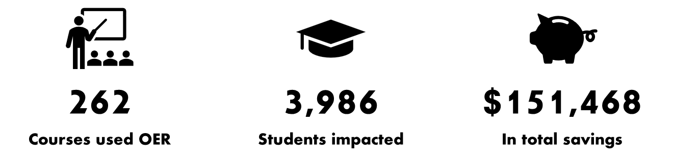
*This course data is from SP 21-SU 22

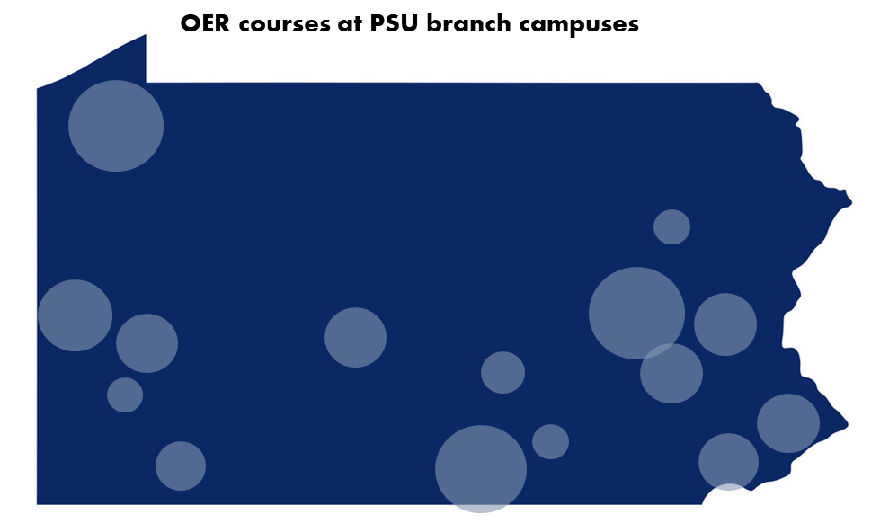
OER usage across Penn State
For the 2021-2022 academic year, the largest number of course sections using OER were in STEM fields, with 43 sections in physics, 27 in mathematics, 23 in chemistry, 18 in biology, 6 in statistics, 5 in astronomy and astrophysics, 3 in information sciences and technology, and 1 in microbiology. OER use was reported at 15 campuses, including Abington (7 course sections), Altoona (7), Beaver (19), Behrend (24), Berks (7), Brandywine (6), Fayette (5), Greater Allegheny (3), Harrisburg (4), Lehigh Valley (15), Mont Alto (21), New Kensington (7), Schuylkill (25), Wilkes-Barre (3), and York (3). The course sections were taught by 69 different faculty (45 non-tenure-line and 24 tenure-line).

Assessment/Survey Results

Faculty Survey
In April and May 2022, we also conducted a survey of faculty to better understand their attitudes toward OER and open pedagogy at Penn State and toward the University Libraries’ support of such efforts. This survey was distributed to academic units across the University via the Libraries’ Open Liaisons, and it was completed by 249 faculty.
“It has saved my students both a lot of headaches and a lot of money. It has also saved me time and energy trying to help students to navigate and scramble to obtain expensive materials at the start of the course. Finally, OER allows me to mix and match course materials that are going to be the most useful and organized for my specific course and pedagogical approach.”
A majority of respondents indicated that they were at least somewhat familiar with OER and that they had at least some awareness that the Libraries take an active role in promoting and supporting OER.
At the same time, only 25% indicated that they had learned about OER via a library presentation, whereas the most common source of learning about OER was through colleagues (32%).
Of those who were familiar with OER, 54% had used it in a course. The majority of faculty who had used OER reported that it was a positive experience, and 85% of those who had not indicated that they would consider using it. Those who had a positive experience using OER in the classroom attributed this to factors such as cost avoidance for students, accessibility, ease of use, customizability, perceived quality, and the availability of helpful support for OER adoption.
All survey respondents were also given the opportunity to provide open-ended comments regarding the Libraries’ support for OER. The most common themes among the responses were that OER is necessary and desirable and that the Libraries provide quality support services for adopting OER. However, some suggested that Penn State needs to couple its promotion of OER with more tangible support (e.g., course release, financial remuneration) and recognition in the promotion and tenure process. All respondents also indicated their interest in a range of opportunities to learn more about OER.

Librarians & Instructional Designers Survey

“Going forward, I need to be much more conversant with the specifics of what the University can supply and how my faculty and I can avail ourselves of them. My own unfamiliarity is a barrier."
–Instructional Designer
A survey of the OER needs of librarians and instructional designers conducted in Spring 2022 provides insights into the needs of library employees who have already developed awareness of OER or are actively working in this area (see full report). Many respondents (74% of library faculty and 78% of instructional designers) promote open education in their interactions with faculty. Of those library employees surveyed who are not promoting OER, the most commonly cited reason was a lack of familiarity or comfort with the content. A few library employees also reported that they had tried promoting OER in the past and had encountered lack of interest from faculty. There was a strong interest in further OER-related training and library faculty expressed the most interest in professional development opportunities around leading OER programs for faculty. Specific requests included funding for faculty, ways to connect faculty with each other, tips for communicating the value of OER to departments and administrators, and strategies for working with faculty.

NLCG Survey

In Spring 2022, students from the Nittany Lion Consulting Group, a student-managed, faculty-supported consulting firm, conducted a survey of Penn State students on behalf of the OAER Working Group. Completed by 305 students, primarily from University Park, the survey asked about experiences related to the purchase and use of course materials. Results indicated that only 24% of students buy all of their required course materials, while the majority (73.%) buy a few.

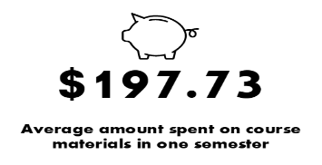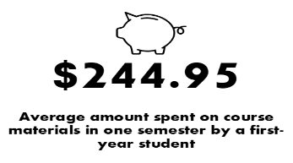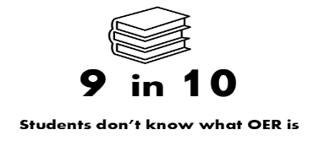
The average amount that respondents spent on textbooks per semester was $197.73, with a maximum of $520 and minimum of $0. These costs were even higher during the first semester of their first year, with an average spending of $244.95, maximum of $600, and minimum of $0. Students were also largely unaware of open and affordable educational resources at Penn State, with only 10% indicating that they had heard of them previously. The full details of the survey can be found in NLCG’s survey analysis report.

Student Focus Groups
In April 2022, the Libraries OER and Open Pedagogy Strategic Action Team conducted three focus group sessions with undergraduate students from across the University who have taken courses that used OER rather than commercially produced course materials. These focus group sessions, though anecdotal in nature, revealed several instructive recurring themes. Students interviewed seemed largely unaware of the term “OER” or any particular sense of a “movement” surrounding the affordability of course materials. Nor were they especially aware of what distinguishes OER from other types of learning materials in terms of licensing, social mission, or the potential novel pedagogical opportunities they may afford.
“The OER actually helped me out because this is all free. I don’t have to worry about paying it. This just basically helps me focus strictly on my courses without any other distractions, and that helps me improve my knowledge overall. So, it definitely did help me in my overall classes versus textbooks."
Instead, students’ primary concerns with respect to educational resources were, rather unsurprisingly, almost solely in the cost of materials and the ease with which they can navigate resources throughout their coursework. In particular, students consistently cited a lack of smooth integration of OER and other digital materials into learning frameworks like Canvas to be a common source of frustration. Indeed, interviews suggest a “seamless” experience using their materials may be as important a factor to students as their cost.
"I loved the course materials and thought it was a great idea to use Open Educational Resources for this course. I feel like I learned a lot more from having a variety of links provided than having just one specific textbook."

Achievements

Professional Attainment

AAC&U IOER
Penn State was one of 66 institutions selected to participate in the American Association of Colleges and Universities 2021-2022 Institute on Open Educational Resources. This yearlong institute supports educators in launching, expanding, or hastening campus adoption of free and affordable instructional materials. Penn State’s team, led by Bryan McGeary, included Ann Taylor, Christina Riehman-Murphy, Corey Wetherington, Elizabeth Wright (Chancellor – Hazleton), Larry Musolino, Rebecca Miller Waltz, and Sara Davis.

SPARC Open Education Leadership Program
Christina Riehman-Murphy and Bryan McGeary were selected as fellows in the SPARC Open Education Leadership Program, an intensive professional development program to empower academic professionals with the knowledge, skills, and community connections to lead successful open education initiatives that benefit students. The two-semester program blends online, peer-to-peer, and project-based learning to build a comprehensive understanding of the open education field coupled with practical know-how to take action on campus and beyond. They were among the 21 fellows selected from a competitive application pool for the program’s 2020-2021 cohort. They join previous Open Education Leadership Fellow Corey Wetherington.

OEN Certificate of Librarianship
Reference and Instruction Librarians Lori Lysiak and Elizabeth Nelson participated in the 2022 cohort of the Open Education Network’s Certificate in Open Librarianship. They collaborated with 62 other librarians from around the country to design, build, and implement sustainable and effective open education programs for their local context, culture, and goals. In the process, they participated in formal training, mentorship, and discussions with diverse peer communities to develop strategies for measuring and articulating the impact of open education, to learn how to build and sustain momentum with a variety of campus constituents, and to strategize support for faculty engagement in the creation, adoption, and use of open educational resources. They join previous Penn State graduates of the program, Christina Riehman-Murphy and Bryan McGeary, who was also selected to be an instructor in the 2023 certificate program.

Creative Commons Certificate
As part of their participation in the OAER Leads program, librarians Amy Deuink, Andrew Dudash, Annie Jansen, Emma Beaver, and Katie Odhner completed the Creative Commons Certificate for Librarians program. The Certificate program provides in-depth instruction about Creative Commons licensing and open practices in order to help participants develop comprehensive knowledge about open education and open access. They join previous Penn State graduates of the program, Bryan McGeary, Christina Riehman-Murphy, and Elizabeth Nelson.

Honors and Impact

UNESCO OER Implementation Award for Excellence
Bryan McGeary and Christina Riehman-Murphy were among the winners of the 2021 UNESCO OER Implementation Award. This award recognizes exemplary leadership in advancing the UNESCO OER Recommendation in the winners’ practices.

Publications
Lori Lysiak published the article "Division by division, book by book: Using licensed e-books as a gateway to OERs" in College & Research Libraries News. The article contributes to the professional literature on promoting and sustaining OERs and achieving faculty buy-in through a multiphase project focused on breaking down barriers to OERs at Penn State Altoona.
Christina Riehman-Murphy and Bryan McGeary published the article “Navigating the 5S’s of Open Pedagogy Projects: A Roadmap for Educators“ in the New England Journal of Higher Education. The article discusses The Open Pedagogy Project Roadmap, a project management resource they designed to guide instructors in planning, finding support for, sharing and sustaining open pedagogy projects.
Bryan McGeary contributed to the OER Review Standards and Approval Rubric: United States Edition, a document created by a nationwide group of OER advocates and individuals engaged in supporting the curation and creation of OER for the purpose of curating and creating best practices or standards for OER review and approval.

Affordable Learning Pennsylvania OER Training Course
Elizabeth Nelson, Bryan McGeary, and Emily Bongiovanni (Psychology and Social & Decision Sciences Liaison Librarian, Carnegie Mellon University) co-developed the Affordable Learning Pennsylvania OER Training Course, a 2-week asynchronous online certificate course intended to introduce educators and those working in higher education to Open Education and generate interest in Open Education initiatives on their campus and within their discipline. During its first offering in July 2022, the course was completed by 26 participants from institutions across Pennsylvania. The course has been shared to Canvas Commons to make it more widely available for reuse and adaptation.

Conference Presentations
Penn State Libraries employees presented about topics pertaining to open education at the following state, national, and international conferences:

International
- Christina Riehman-Murphy and Bryan McGeary (July 2022). “Growing Future OER Contributors Through Open Pedagogy,” Conference for Open-Source Coders, Users and Promoters (COSCUP) 2022.
- Christina Riehman-Murphy and Bryan McGeary (May 2022). “Mapping a Course for Open Pedagogy Success,” OE Global 2022 Conference.
- Bryan McGeary and Christina Riehman-Murphy (April 2022). “The Open Pedagogy Project Roadmap: A Resource for Planning and Sustaining Open Educational Practices,” Association for Learning Technology OER22 Conference.
- Christina Riehman-Murphy (April 2022). “Rethinking Coursework: From Students as Argument Makers to Students as Makers of Scholarly Editions,” Association for Learning Technology OER22 Conference.
- Bryan McGeary and Christina Riehman-Murphy (December 2021). “Creating Scalable and Sustainable Initiatives for OER Use and Creation Across a Multi-Campus University System,” German Commission for UNESCO OERcamp.global 2021.
- Christina Riehman-Murphy and Bryan McGeary (December 2021). “Open Pedagogy Project Management: A Packing List for Success,” German Commission for UNESCO OERcamp.global 2021.
- Christina Riehman-Murphy and Bryan McGeary (October 2021). “Open Pedagogy Project Management: A Roadmap for Inclusive, Collaborative, & Sustainable Projects,” Open Education Conference 2021.
- Christina Riehman-Murphy and Bryan McGeary (September 2021). “The Open Pedagogy Project Roadmap: Building Capacity to Create and Sustain Inclusive, Learner-Centered OER,” OE Global 2021 Conference.
- Bryan McGeary and Christina Riehman-Murphy (September 2021). “Building Stakeholder Capacity for OER Use and Creation Through a Multi-Tiered, System-Wide Faculty Development Plan for Open Education at Penn State University,” OE Global 2021 Conference.
- Bryan McGeary and Christina Riehman-Murphy (September 2021). “The Open Pedagogy Project Roadmap: Project Management for Designing, Sharing, and Sustaining Your Open Pedagogy Project,” Creative Commons Global Summit 2021.

National
- Mihoko Hosoi and Bryan McGeary (June 2022). “Finding Opportunities for Open Textbooks,” American Library Association Core Chief Collection Development Officers of Large Research Libraries Interest Group Meeting.
- Bryan McGeary, Mihoko Hosoi, and Lana Munip (May 2022). “Doctoral Students and the Future of OER: Understanding Their Needs, Usage, and Perspectives,” Northeast OER Summit 2022.
- Bryan McGeary, Kristin Heathcock, Jonas Lamb, and Janet Vogel (April 2022). “Overcoming Challenges: Success Stories from Campuses in Our Institute,” American Association of Colleges and Universities 2021-2022 Institute on Open Educational Resources.

State
- Elizabeth Nelson, Bryan McGeary, Christina Riehman-Murphy, Emma Beaver, Annie Jansen, Amy Deuink, Katie Odhner, and Andrew Dudash (August 2022). “LEADing the Way: Building OER Expertise Among Librarians Across a Multi-Campus University,” Affordable Learning PA Summit 2022.
- Christina Riehman-Murphy and Bryan McGeary (May 2022). “Open Pedagogy & the Library,” Temple University Libraries Workshop.
- Bryan McGeary and Melody Diehl Detar (March 2022). “Creative Commons and Open Pedagogy,” OpenEd Western Pennsylvania Open Education Week 2022 Series.
- Michael Polgar, Julie Meyer, Bryan McGeary, and Sara Davis (March 2022). “Collaboratively Creating OER,” 2022 Symposium for Teaching and Learning with Technology.
- Bryan McGeary (November 2021). “Creating a Roadmap for Collaborations with Students as Course Creators and Contributors,” VIVA (Virginia's Academic Library Consortium) Advancing Open Educational Practices Workshop Series.
- Bryan McGeary, Christina Riehman-Murphy, and Sara Davis (October 2021). “Scaffolding Faculty OER Initiatives for Sustainability,” Open Education Network Publishing Cooperative Tea Time.
- Bryan McGeary and Christina Riehman-Murphy (August 2021). “Mapping an Open Pedagogy Project Journey,” Affordable Learning PA Summit 2021.

What’s Next

Center for Open Education
In order to move from pilot and exploratory projects toward integrated and sustainable core functions, the OAER Working Group is pursuing the establishment of a Center for Open Education at Penn State, housed within the University Libraries in order to move into the second phase of programmatic and strategic work. This service center will enable us to develop stronger structures for supporting and advancing OER efforts and establish ourselves as strong collaborators ready to partner with other units, institutions, researchers, and groups. Such a center will provide an administrative home for OER efforts and will aid us in securing the ongoing institutional and development funding necessary to continue and expand our work.

Expanding Grants
With the success of the OER authoring grant (ACT) and the OER adoption grant at Abington, the OAER Working group looks to expand the adoption grant program to every campus. The successful 2021 Giving Tuesday campaign and the Sally W. Kalin endowed librarian position provides the funding which will make this effort attainable. Additional internal and external grant funding will also be sought to investigate implementing open homework systems and developing open pedagogy grants that fund students for their work in developing Penn State authored OER.

Increase Support for Penn State OER Authors
While we already provide a range of services to Penn State faculty and staff who want to create their own OER, we have identified additional in-demand services that we do not currently have the capacity for. In particular, the OER authors that we have spoken to would like support to have their OER copyedited and peer reviewed in order to better ensure that their quality is comparable to commercially produced course materials. Increasing numbers of faculty are indicating an interest in involving their students in OER creation and adaptation.

Improve Data Collection
Marking course sections that use no-cost ($0 cost to the student) and low-cost (less than $50) resources as required course materials is a growing part of the college and university affordability landscape. “Course Marking” is commonly done by adding some type of notation to a course section in the course registration system so that students can readily see that information when making course selection decisions. A sub-committee of the OAER Working Group is working on a Course Marking Initiative that would provide course schedulers with the opportunity to “mark” a course section as no-cost or low-cost by assigning an appropriate attribute to that section in LionPath. This work is anticipated to be piloted with the Spring 2024 semester course offerings.

Appendix: Sources

Clinton, V., Legerski, E., & Rhodes, B. (2019). Comparing student learning from and perceptions of open and commercial textbook excerpts: A randomized experiment. Frontiers in Education, 110(4). https://doi.org/10.3389/feduc.2019.00110
Colvard, N.B., Watson, C.E., & Park, H. (2018). The impact of open educational resources on various student success metrics. International Journal of Teaching and Learning in Higher Education, 30(2): 262-276.
DOERS3. (2020). Accelerating adoption of OER in the era of COVID-19. https://www.doers3.org/covid19.html
Froehlich, H., Nicosia, M., & Riehman-Murphy, C. (2022). Transcribing recipe manuscripts online: V.b. 380 and the “What’s in a Recipe?” undergraduate research project at Penn State Abington. Early Modern Studies Journal, 8: 23-41. https://earlymodernstudiesjournal.org/review_articles/transcribing-recipe-manuscripts-online-v-b-380-and-the-whats-in-a-recipe-undergraduate-research-project-at-penn-state-abington/
Griffiths, R., Mislevy, J., Wang, S., Ball, A., Shear, L., Desrochers, D. (2020). OER at scale: The academic and economic outcomes of Achieving the Dream’s OER Degree Initiative. Menlo Park, CA: SRI International.
Hilton, J., Fischer, L., Wiley, D., Williams, L. (2016). Maintaining momentum toward graduation: OER and the course throughput rate. International Review of Research on Distance and Open Learning, 17(6). https://doi.org/10.19173/irrodl.v17i6.2686
Iowa Open Education Action Team. (2022). Open education initiatives in Iowa. https://iowaoer.wordpress.com/
Nascimbeni, F., Burgos, D., Spina, E., & Simonette, M.J. (2021). Patterns for higher education international cooperation fostered by Open Educational Resources. Innovations in Education and Teaching International, 58(3), 361-371. https://doi.org/10.1080/14703297.2020.1733045
Ozdemir, O., & Hendricks, C. (2017). Instructor and student experiences with open textbooks, from the California open online library for education (Cool4Ed). Journal of Computing in Higher Education, 29(1): 98-113. https://doi.org/10.1007/s12528-017-9138-0
SPARC. (n.d.). Open education. https://sparcopen.org/open-education/
NACS (2022, August). NACS student watch report: Course materials spending dropped. https://www.nacs.org/nacs-student-watch-report-course-materials-spending-dropped

